An Approach for RAG Performance Improvement Based on User Requests Predicting and Interests Modelling

Nikolay Butakov, Ilya Popov
National Research University ITMO
Saint Petersburg, Russian Federation
ilya.s.popov@mail.ru

Abstract— This study investigates methods for generating contextually relevant subsequent questions in conversational question-answering (QA) systems. Using the CoQA dataset and the Qwen3-4B-Instruct-2507 language model, we propose and evaluate three distinct approaches for predicting a user's next questions within a dialogue. The first approach identifies the dialogue's core topic and its aspects from initial user questions to guide generation. The second incorporates information from topically similar dialogues via clustering to enrich the generation context. The third bypasses explicit topic modeling, generating questions directly from the source text narrative. Our evaluation, which measures the expected value of the percentage of successfully predicted test questions, reveals that the topic-and-aspect-driven first approach (EV=3,1%) outperforms both the multi-dialogue cluster-based approach (EV=2,4%) and the direct context-based approach (EV=2,4%). The results indicate that a user's own question patterns provide stronger predictive signals than external context or similar dialogues, with information overload and noise from contextual details potentially hindering prediction accuracy in alternative approaches.

Introduction
Dialogue systems increasingly rely on predictive capabilities to anticipate user needs and provide proactive assistance. Understanding the sequential nature of human questioning, where subsequent queries often build upon previous context, is crucial for developing responsive conversational agents. This research addresses the fundamental challenge of question prediction in multi-turn dialogues by examining three methodological approaches using the CoQA dataset, which contains 7,199 dialogues with contextually interconnected questions.
...
This paper introduces and compares three different approaches for question generation within this conversational framework:
- Topic- and aspect-driven generation: this approach treats each dialogue in isolation. It first uses the initial 60% of a user's questions to induce the dialogue's overarching topic. Subsequently, it identifies specific aspects of this topic. Finally, it uses the induced topic, aspects, and the PQ to generate new questions
- Cross-dialogue: this approach leverages the hypothesis that users engaged in similar topics may ask analogous questions. For a target dialogue, question generation is then informed not only by its own topic and questions but also by the aspects and questions from other dialogues within the same cluster, aiming to enrich the generative context.
- Direct context based generation: this approach, it provides the LLM directly with the source text (story) context from the CoQA dataset alongside the user's questions
II. Literature overview
The task of automated Question Generation (QG) is defined by key methodological choices, primarily the scope of the input context and the dependency on a target answer. Context can be provided at a paragraph level, utilizing full textual passages, or at a keyword level, operating on a set of core terms. Furthermore, QG approaches are categorized as either answer-aware or answer-agnostic [1]. Answer-aware methods take a known answer as input and generate a corresponding question grounded in a provided context. Answer-agnostic methods generate questions directly from the context without a pre-specified answer target [2]. In paper [3] authors in order to generate questions, first use LLM to generate an answer plan based on the given context and predefined requirements. This plan contains several candidate answers or answer-containing sentences. During the last step, generated plan, context and prompt are given to the QG models to generate question-answer pairs. Answer-agnostic approach in paper [4] used 100 different texts from different domains to generate multiple questions from each text.
Rather than generating questions from raw text alone, leveraging explicit topic representations provides a structured semantic framework that guides the generation process toward more coherent, focused, and contextually appropriate inquiries [5]. Zhang et al. [6] combine topic modeling and large language models (LLMs) to generate questions from large volumes of user feedback. Each topic is represented as a probability distribution over all words in the vocabulary, so authors use only top words with the highest probabilities to describe a topic. These topics are then used to find documents that are semantically similar to the them, to further feed them to the LLM to generate a natural-language question. In work [7] CoQA dataset is used as a training data for transformer model. Using BERTopic [8] topics are extracted as a cluster of related keywords from the conversation history, which includes both questions and answers. Then extracted topics, question-answer pairs and text context are used to generate next question in a conversation.
To evaluate generated questions quality metrics like BLEU [9], BERTScore [10], ROUGE [11] are often used in research [2, 3, 12]. Another approach is to use LLM-as-a-judge [13]. In paper [14] LLM-as-a-judge is used to compare answers to generated questions. Specific prompts are used focusing on semantic quality only (ignoring formatting, tone, etc.) and evaluation results are aggregated using a scoring system.
III. Methodology
In this research CoQA dataset is used. The dataset contains 7199 dialogues with different number of questions each. Questions are interconnected, often relying on context from previous turns in the dialogue. To conduct a controlled experiment, this study specifically analyzes the subset of dialogues containing exactly 20 questions.
The LLM used in this research is Qwen3-4B-Instruct-2507.
A. First approach
The first approach considers each dialogue separately. To generate potential questions, the user's dialogue topic is first identified. To do this, the questions are divided into sections: the first 60% of questions (in this case, 12) will be used to feed the model, while the remaining 40% (8) will be used later as test questions (Fig. 1). From now on we will refer to these questions as prompt questions (PQ) and evaluate questions (EQ) So, the PQ are passed to the LLM as a prompt, and the model outputs the topic of the dialogue.
The next step in this approach is to define the aspects of the identified topics. To do this, the previously identified topics and the same 12 questions are fed into the LLM’s promt.
To generate questions, the identified topics, aspects, and the first 60% of questions are passed to the LLM’s prompt.
Finally, at the end, the generated questions are compared with the EQ that weren't passed to the LLM’s prompts. This is done using a LLM-as-a-judge technique that compares each question to each other. The comparison uses a scale from 0 to 1, where 0.5 is “Possibly equivalent (similar intent but different phrasing)”. Therefore, pairs of questions that yield a result no less than this threshold are considered similar.
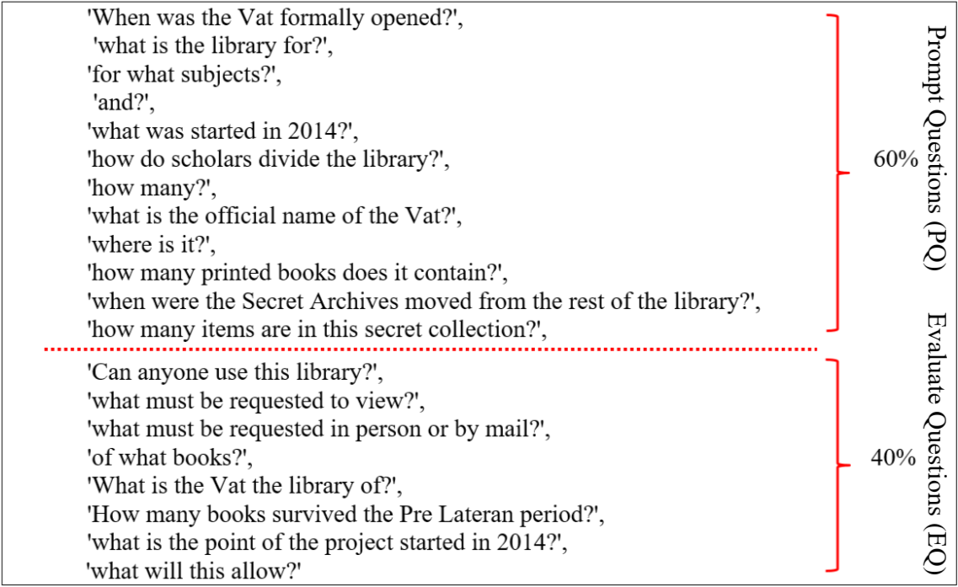
Fig. 2. An example of dividing a set of questions into parts
B. Second approach
The second approach is based on the idea that users from the same department or with similar topics may ask similar questions. By using information from these other similar dialogues, we can predict the user's likely question.
To simulate this scenario, where we have dialogues with similar topics, 1000 dialogues were considered. Each of these dialogues also contains exactly 20 questions. Based on the context of the dialogue, the topic of the dialogue was extracted using LLM. Next, using DBSCAN (Density-Based Spatial Clustering of Applications with Noise), the topics of the dialogues were grouped into clusters.
The approach follows the logic of the first approach, but with slight modifications. First, each cluster is considered separately. Since the topics of each dialogue have already been defined, the next step is to identify aspects of the topic. However, whereas the previous approach used topic and PQ from the dialogue under consideration, this approach additionally uses PQ from the remaining dialogues in the cluster to identify aspects.
Next, to generate questions, the topics, aspects and PQ of the dialogue under consideration, as well as aspects and PQ of other dialogues in the cluster, are used.
At the end, the same procedure is carried out to compare the generated questions with the EQ for each dialogue separately.
C. Third approach
The third approach differs from the previous ones in that it eliminates the step of identifying topic and aspects of the dialogue. Instead, questions are generated based on the context found in each dialogue in the CoQA dataset. The dialog context and the PQ are passed to the LLM’s prompt for question generation. The same question comparison procedure is then performed.
Fig. 2 shows flowcharts for each approach.
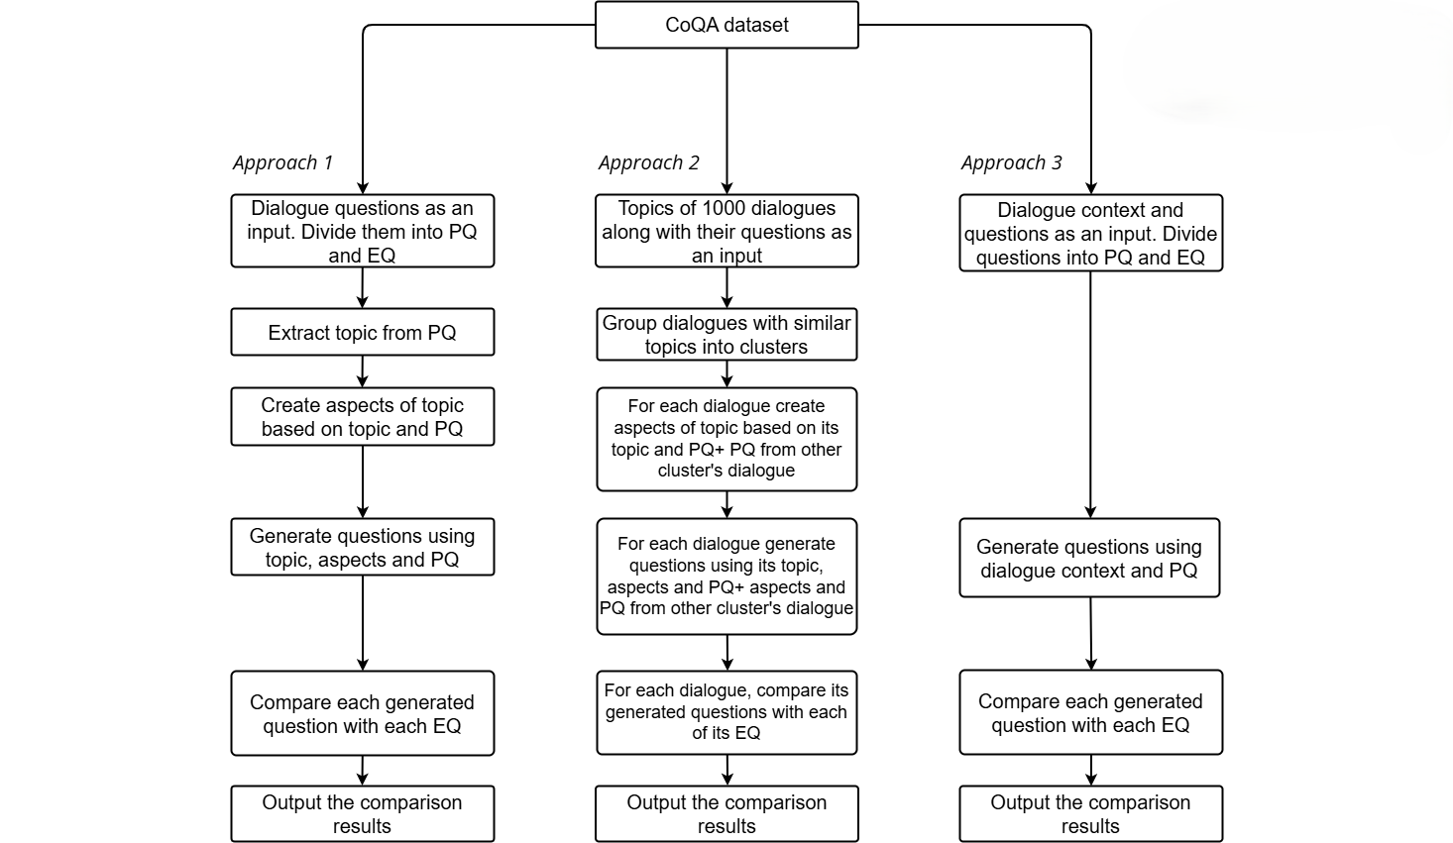
Fig. 2. An example of dividing a set of questions into parts
For approaches 1 and 3, 100 identical dialogues with 20 questions were considered. For the second approach, a total of 85 dialogues were used, grouped into 20 clusters.
IV. Conclusion
A. Equations
To evaluate the effectiveness of each question generation approach, Expected Value (EV) can be calculated:
$$EV=\frac{1}{N}\sum_{i=1}^{N}{\left(\frac{T_{i}}{M}∙100\%\right)}$$
where N is a total number of dialogues, T is a number of successfully predicted test questions in dialogue i, M is a total EQ per dialogue (8 in our case).
This metric represents the average percentage of test questions per dialogue that can be predicted. Table I shows results for three approaches.
TABLE I. EV comparison across question generation approaches
Approach | Approach Description | EV
Approach 1 | Topic and aspects based question generation | 3,1
Approach 2 | Domain and aspects based question generation | 2,4
Approach 3 | Context-based generation from user questions | 2,4
The results show that the first approach outperforms the other two. The worse performance of the second approach can be explained by the fact that information from other dialogues did not fully help the model predict the questions of this approach. For example, in the first cluster, which is united by “children's/adult’s” topic, each dialogue asks questions about different books (Harry Potter, The Outsiders, Charlotte's Web, The Miraculous Journey of Edward Tulane, Bamboo People etc.). While these dialogues may be united by a common topic, the questions themselves, and the plots of the books themselves, differ.
The third approach, surprisingly, also performed worse than the first. Even though the model was fed the full context of the user's questions along with PQ, it was unable to reliably predict the questions. This may indicate that user's own questions are a stronger predictor of their future inquiries than external context. The story context, while factually rich, introduces noise by including details irrelevant to the user's specific focus, causing the model to generate plausible but x questions. In other words, thied approach (using story context + PQ) likely failed due to information overload and noise introduction.

References
- Zhang, R., Guo, J., Chen, L., Fan, Y., Cheng, X., 2021. A review on question generation from natural language text. ACM Transactions on Information Systems (TOIS) 40, 1–43.
- Lopez, L.E., Cruz, D.K., Cruz, J.C.B., Cheng, C., 2020. Simplifying paragraph-level question generation via Transformer language models. https://doi.org/10.48550/arXiv.2005.01107
- Li, K., Zhang, Y., 2024. Planning first, question second: An llm-guided method for controllable question generation, in: Findings of the Association for Computational Linguistics ACL 2024. pp. 4715–4729.
- Al Faraby, S., Romadhony, A., Adiwijaya, 2024. Analysis of LLMs for educational question classification and generation. Computers and Education: Artificial Intelligence 7, 100298. https://doi.org/10.1016/j.caeai.2024.100298
- Karri, P., Reddy, G., Vignesh, D., Pavan, A., Vamsi, T., Rishi, K., Kumar, K., 2025. Automated Question Paper Generator Using LLM. International Journal of Research and Innovation in Applied Science X, 266–275. https://doi.org/10.51584/IJRIAS.2025.10040020
- Zhang, D., Wang, J., Nayak, R., Bashar, M.A., 2024. Topic Models Meet LLMs: Generating Insightful Questions from User Feedback, in: The 22nd Australasian Data Science and Machine Learning Conference.
- Mulla, N., Gharpure, P., 2023. Genetic Algorithm Optimized Topic-aware Transformer-Based Framework for Conversational Question Generation. Procedia Computer Science 230, 914–922. https://doi.org/10.1016/j.procs.2023.12.041
- Grootendorst, M., 2022. BERTopic: Neural topic modeling with a class-based TF-IDF procedure. arXiv [cs.CL]. https://doi.org/10.48550/ARXIV.2203.05794
- Papineni, K., Roukos, S., Ward, T., Zhu, W.-J., 2002. Bleu: a method for automatic evaluation of machine translation, in: Proceedings of the 40th Annual Meeting of the Association for Computational Linguistics. pp. 311–318.
- Zhang, T., Kishore, V., Wu, F., Weinberger, K.Q., Artzi, Y., 2019. Bertscore: Evaluating text generation with bert. arXiv preprint arXiv:1904.09675.
- Lin, C.Y.: ROUGE: A package for automatic evaluation of summaries. In: Text Summarization Branches Out. pp. 74–81. Association for Computational Linguistics, Barcelona, Spain (Jul 2004), https://www.aclweb.org/anthology/W04-1013
- Pan, B., Li, H., Yao, Z., Cai, D., Sun, H., 2019. Reinforced Dynamic Reasoning for Conversational Question Generation. https://arxiv.org/abs/1907.12667
- Chiang, C.-H., Lee, H.-Y., 2023. Can large language models be an alternative to human evaluations? https://arxiv.org/abs/2305.01937
- Chen, G.H., Chen, S., Liu, Z., Jiang, F., Wang, B., 2024. Humans or llms as the judge? a study on judgement biases. https://arxiv.org/abs/2402.10669
- Reddy, S., Chen, D., Manning, C.D., 2018. CoQA: A Conversational Question Answering Challenge. https://arxiv.org/abs/1808.07042
- [16] Qwen, Yang, A., Yang, B., Zhang, B., Hui, B., Zheng, B., Yu, B., Li, C., Liu, D., Huang, F., Wei, H., Lin, H., Yang, Jian, Tu, J., Zhang, J., Yang, Jianxin, Yang, Jiaxi, Zhou, J., Lin, J., Dang, K., Lu, K., Bao, K., Yang, K., Yu, L., Li, M., Xue, M., Zhang, P., Zhu, Q., Men, R., Lin, R., Li, T., Tang, T., Xia, T., Ren, Xingzhang, Ren, Xuancheng, Fan, Y., Su, Y., Zhang, Y., Wan, Y., Liu, Y., Cui, Z., Zhang, Z., Qiu, Z., 2024. Qwen2.5 Technical Report. https://arxiv.org/abs/2412.15115.

